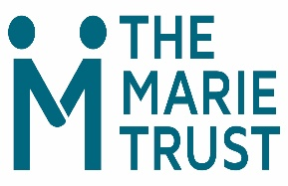
Counselling Service Referral Form – Agency Referral Form
Submission of this form will be treated in the strictest of confidence

Client’s Name:
Date of Birth:
Gender:
Ethnicity:
Contact Number:
Address:

Some personal information about reasons for counselling.
Current accommodation situation:

Does the client have recent history of homelessness? This includes any situation where they did not have their own secure living arrangement e.g. temporary furnished flat, sofa-surfing, rough-sleeping and B&B/hostel.
(Please note that if the client does not have a recent history of homelessness, we will be unable to accept the referral.)

Has this referral been discussed with the client?

Reasons for referral
(Why is the client looking to access counselling right now?)

Please list any other services you are aware of that are currently supporting this client:

Summary of client’s support needs (please advise if the client has a disability, mental ill health, issues relating to substance dependence, including anything they are awaiting a confirmed diagnosis of):

Risk Management (please advise if you are aware of any issues that exist that may indicate that the client may pose a risk to the well-being of others or themselves)

Are there any concerns with the client working with a male/female therapist?

Generally, we see clients at The Marie Trust, 29 Albion Street Glasgow unless they are residents of the Chara Project.
Does the client have a preference for counselling via the following?
Albion Street
Telephone counselling.
x
Online counselling
x

Any other relevant information that you think it would be useful for us to know (optional):

Name of Referrer:
Organisation & Address:

Designation:
Contact No:
Date of Referral (today’s date):

Once completed, please email this form to David Crossley: DCrossley@themarietrust.org.uk
If you would like to discuss this referral in advance you can call David 07483165983

