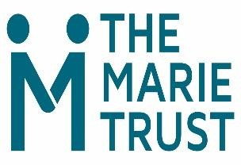
Trust Counselling Service Self - Referral Form
Submission of this form will be treated in the strictest of confidence

Name:
Date of birth:
Telephone no:
Address:

Some personal information about reasons for counselling.

Are you currently homeless? Yes ○ No ○

(We regret that unfortunately we are currently unable to begin to offer a service to people who are in permanent accommodation)

What best describes your accommodation status?

Rough Sleeping ○ B&B ○ TFF ○ Hostel ○ Sofa surfing ○ NFA ○ other ○

Reason for Counselling (optional)

Reason for Counselling (optional)

The service runs at several venue. Please indicate your preference
- The Marie Trust
- Chara Centre (residents only)
- Over the Phone (during lockdown or in specific circumstances)
- Other preferred venue, this could be supported accommodation, NHS premises.

You can access the service by:
- Speaking with a member of staff; or
- Phoning or Texting David 07483165983.
- Completing the Form on the page above and handing it in or emailing DCrossley@themarietrust.org.uk
- Asking a Professional to Refer you (the referral form can be sent via email or downloaded from our website)
OFFICIAL - Sensitive

